**Project Report: Detection of Online Sexism Using Bi-LSTM Model**

**Group Members:**

1. **Kamran Hassan Shomrat -21101010**
2. **Moinuddin Zubair -21101223**
3. **Tarannum Ahmed Nowshin -21101210**

**Introduction:**

Sexism, which is defined as any mistreatment or unfavorable treatment of women based solely on their gender or in conjunction with other identifying characteristics like ethnicity, religion, or gender identity, is still a problem on online platforms. This pervasive issue not only makes people who are affected by it feel distressed emotionally, but it also fosters a climate of hostility and seclusion that perpetuates social injustices. While automated techniques are increasingly being employed for the large-scale identification and assessment of sexist content, many of these systems just offer broad classifications without any further explanation or context. Automated decision-making systems can be made more comprehensible, trustworthy, and interpretable by not just recognizing and categorizing sexist content but also providing explicit explanations for our findings.

**Dataset:**

1. Dataset Source: A range of internet resources, including social media, forums, and comment sections, are probably where the text samples came from.
2. Annotations: Every text sample in the dataset has been labeled according to the presence or absence of sexist material. Furthermore, sexist content is further divided into classifications that characterize the exact kind and degree of sexism displayed.
3. Labels: The dataset contains labels like "derogation," "threats," and "animosity," as well as subcategories like "incitement of harm," "dehumanizing attacks," and "gendered slurs," among others.
4. The Dataset is divided into 5 sections namely rewired, text, label category, label vector.
5. There are in total 14000 data rows and 5 data columns.
6. Quality Control: To ensure that the annotations are accurate and consistent, quality control procedures were probably applied to the dataset. This guarantees the dataset's dependability when used for study and analysis.
7. Data Format: The dataset is likely provided in a structured csv format facilitating easy integration into various analytical tools and platforms.
8. Balanced Representation: During the data collection process, efforts might have been taken to guarantee a fair representation of the various situations, subjects, and linguistic idioms that are frequently encountered in online discussions. This guarantees that a wide range of sexist words and actions are captured in the dataset.

**Model:**

**Pictures of Task 1**

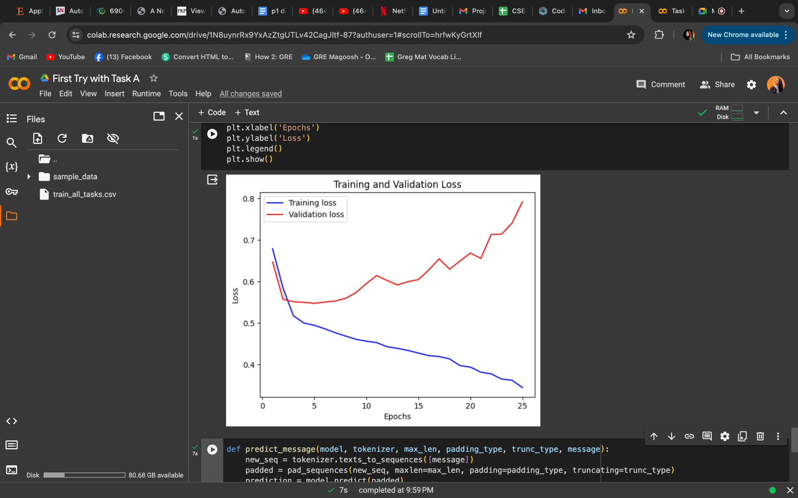

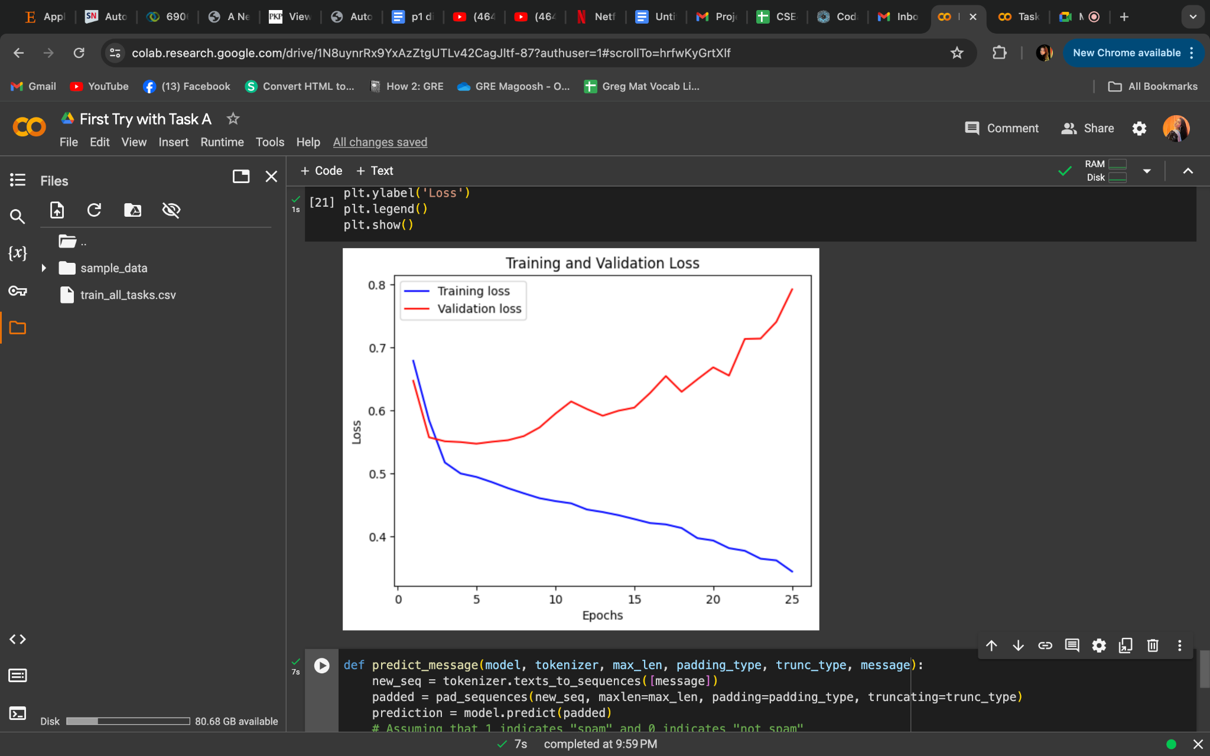

**Pictures of Task 2**

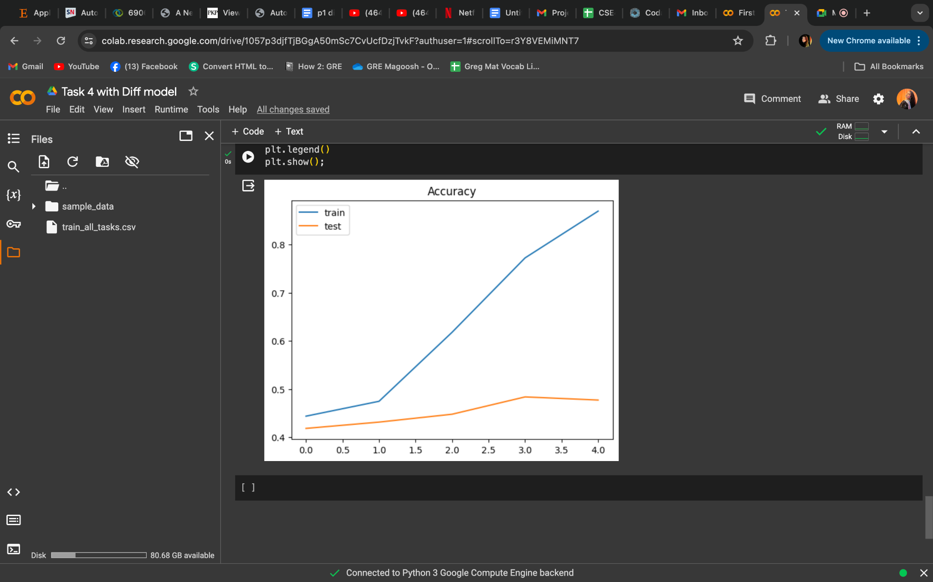

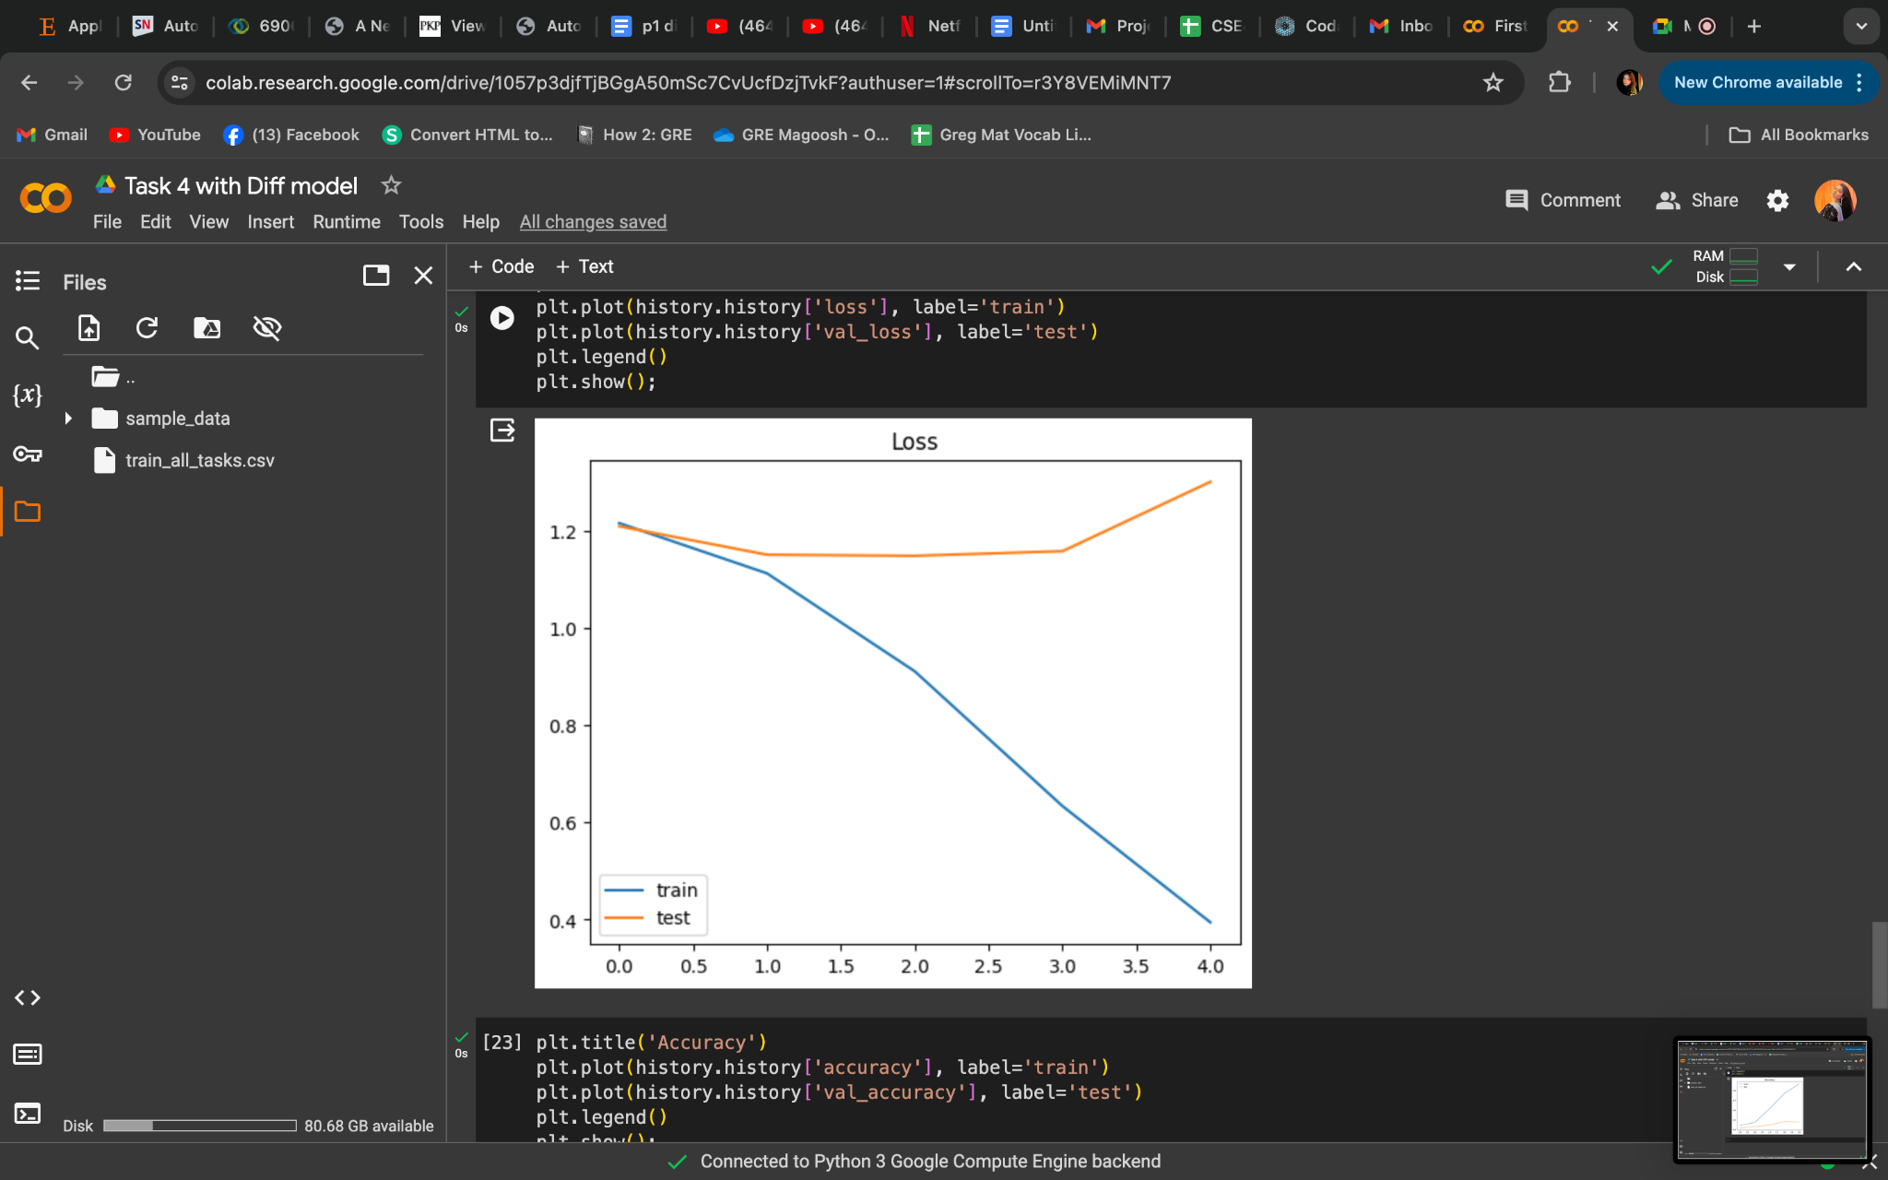

**Parameters:** In our binary classification project, the Parameters of the LSTM model play a crucial role in shaping the architecture and ultimately influencing the model's performance. With an LSTM layer size of 128, we aim to capture intricate temporal dependencies within the sequential data, allowing the model to discern patterns effectively. To prevent overfitting and enhance generalization, we've implemented a dropout rate of 0.2 within the LSTM layer, strategically disregarding a portion of the neurons during training iterations. This regularization technique encourages the model to learn robust representations from the data while minimizing the risk of memorizing noise. Furthermore, with an embedding dimension of 16, we transform the input categorical variables into dense vectors, facilitating the model's comprehension of semantic relationships and improving its ability to extract meaningful features from the textual data. Throughout the training process spanning 30 epochs, these parameters undergo iterative adjustments, fine-tuning the model's performance and convergence towards optimal decision boundaries, thus empowering our LSTM-based classifier to make accurate predictions in our binary classification task.

**How many times data was cleaned:** The data was cleaned multiple times before training the Bidirectional LSTM model for the binary classification project. For instance, initially, it was cleaned for Null values.

**Result :**

For task A, training accuracy 85.87% and validity accuracy: 68.68

and For Task B accuracy came as 48.5% and Loss: 1.223

Bidirectional LSTM networks are widely used in NLP due to their knack for grasping contextual cues from input sequences. By analyzing data forwards and backwards, they gain a holistic understanding of word connections within sentences, making them proficient in tasks such as text generation and sentiment analysis. Furthermore, they alleviate the issue of vanishing gradients in deep neural networks by incorporating information from distant parts of the sequence, thereby enhancing their ability to learn from long-range dependencies. Overall, bidirectional LSTMs provide a strong solution for NLP challenges, effectively managing sequential data and tackling issues related to long-term dependencies.

There have been significant advancements in natural language processing (NLP) beyond bidirectional LSTM networks, with models like BERT, GPT, and Transformer-based architectures leading the way. These models, leveraging techniques such as self-attention mechanisms and pre-training on large text corpora, have demonstrated remarkable performance across various NLP tasks. BERT and its variants excel in understanding contextual information, while GPT models are proficient in generating coherent text. These models offer a range of options for developers and researchers seeking to tackle complex language understanding and generation tasks.